A000-AM,C-Colima-Platform Figure Circa 300BCE-300CE.

Case No. 9

Size 4 3/4" X 3 1/2 " x 4". A fine Colima litter figure depicting a seated figure with hands held to up-raised knees seated inside a covered hut/litter. Four knobs, two in the front & two in the back probably was for four attendants that would carry the seated lord around. Sold by Artemis Gallery May of 2015.

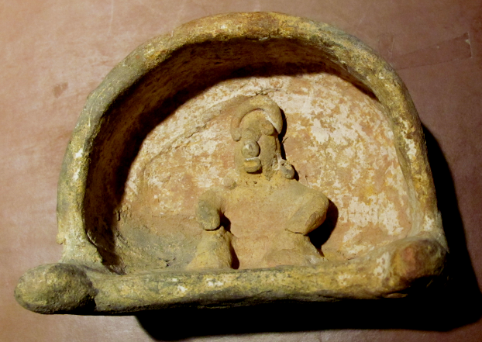

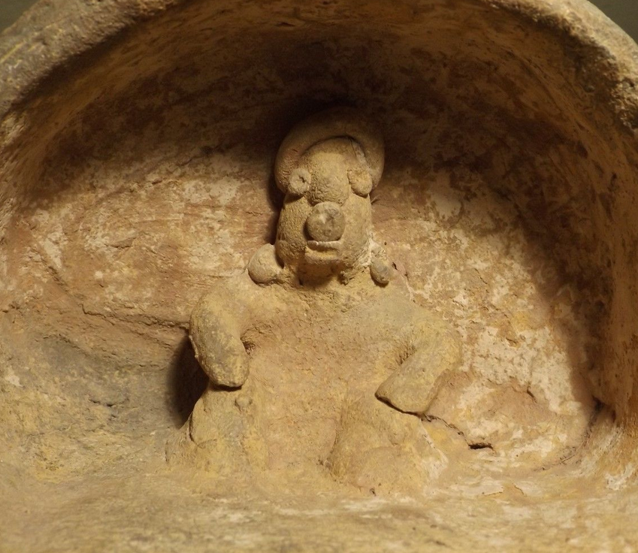 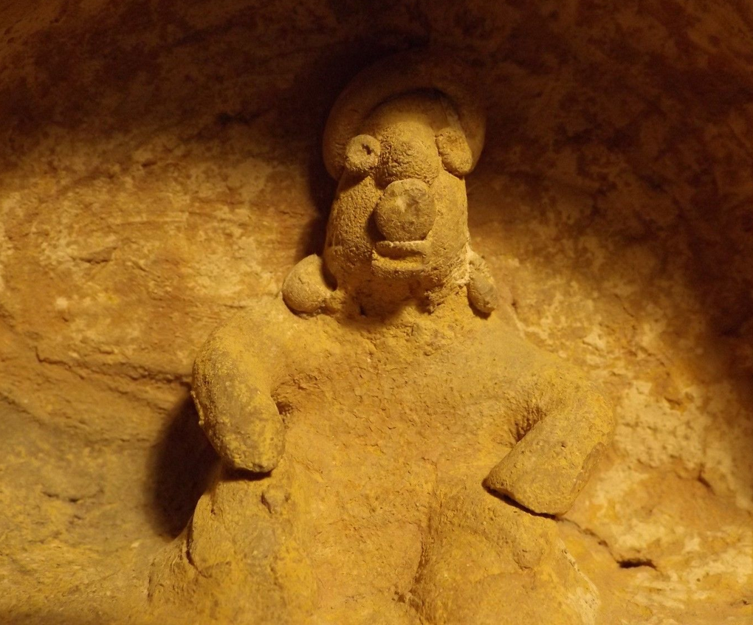

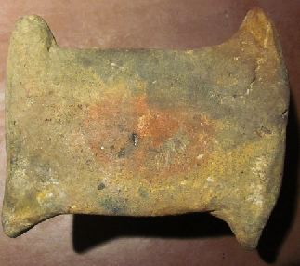

Two  Large Seated Precolumbian Colima Ruling Figures, male and female. 6" high x 4" across. They both have distinctive turban style headdresses, the male has ear spools, a necklace, epaulets, a waist band and a kilt. The female has arm bands and a necklace The female has stress cracks and chips on hand, with a nose reattached, and a missing right ear; the male has a chipped nose, necklace and right foot and head reattached. These two figures appear to not have been from the same shaft grave but interred separately due to the very different treatment and modeling of the eyes, mouth and hands..

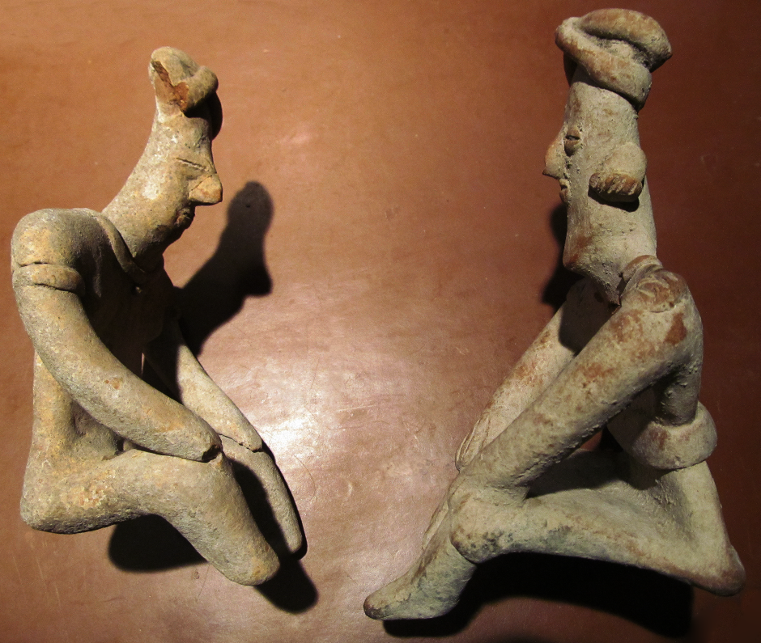

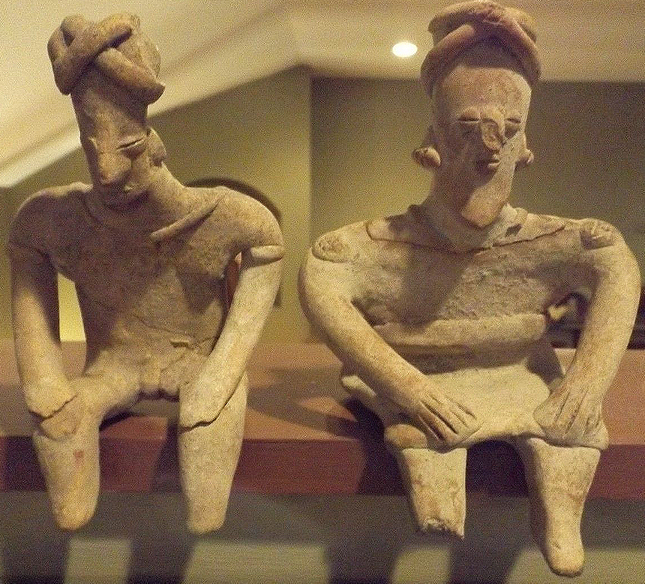

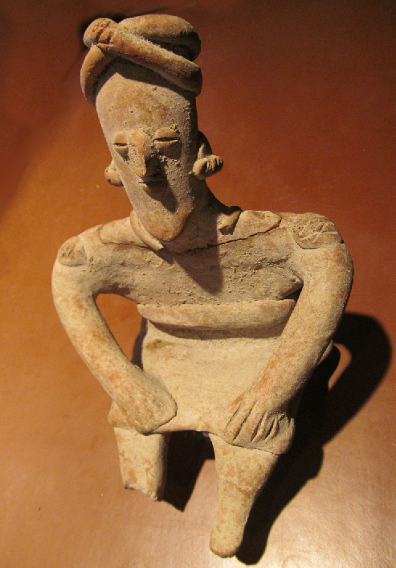 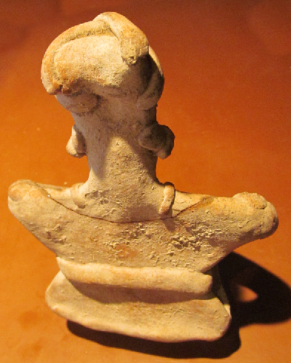

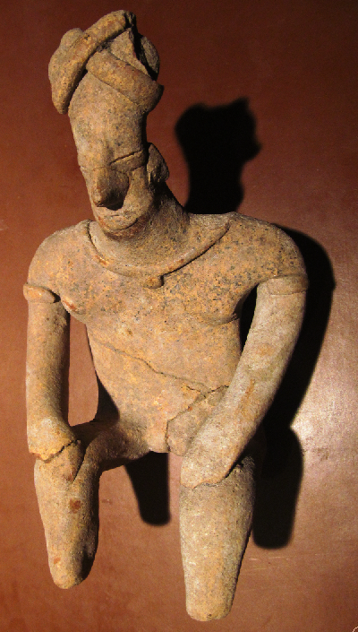 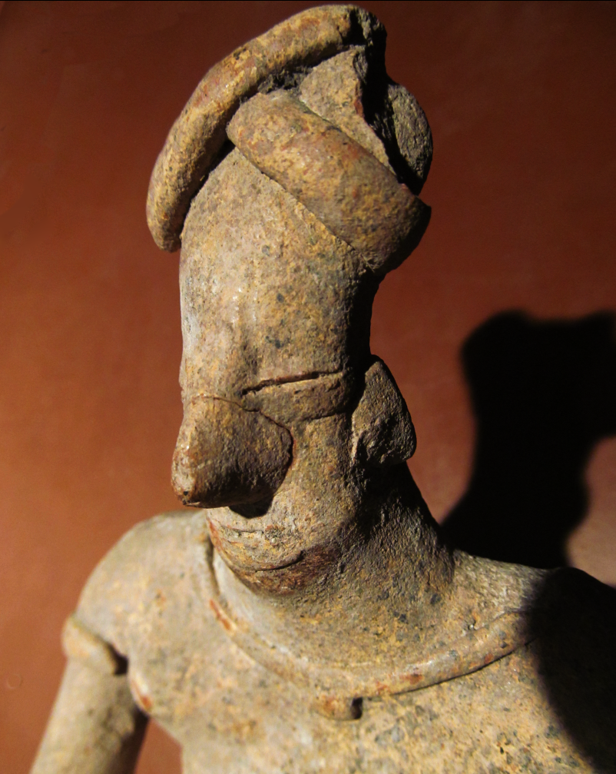

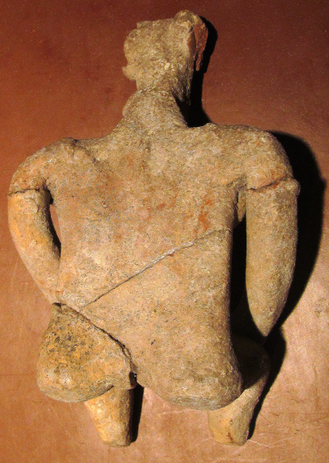

This pre-Columbian pottery artifact wears the headdress of the Sun God. He is about 1,800 years-old and was recovered from the ancient Colima culture in Western Mexico prior to 1970. It is in Very Good to Excellent, Museum Quality condition and has a wonderful patina with only minor formation of authentic, black dendrite crystals on its surface.